

**ITE1007- Object oriented analysis and design**

**Title: Near Field Communication**

Name: Sri Harshitha Palla

Reg. no: 17BIT0330

Contact no: 9949036116

Signature:

Name: Garlapati Saiteja

Reg. no: 17BIT0217

Contact no: 8985762222

Signature:

Name: Ranadeeshwar

Reg. no: 17BIT0133

Contact no: 9080183127

Signature:

1. Collaboration Diagram

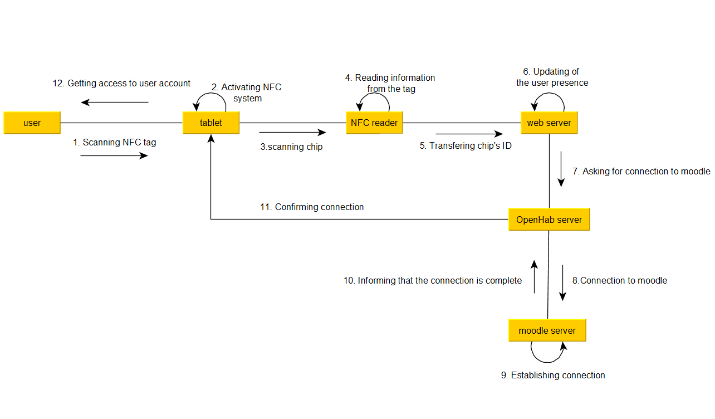

1. Object Diagram

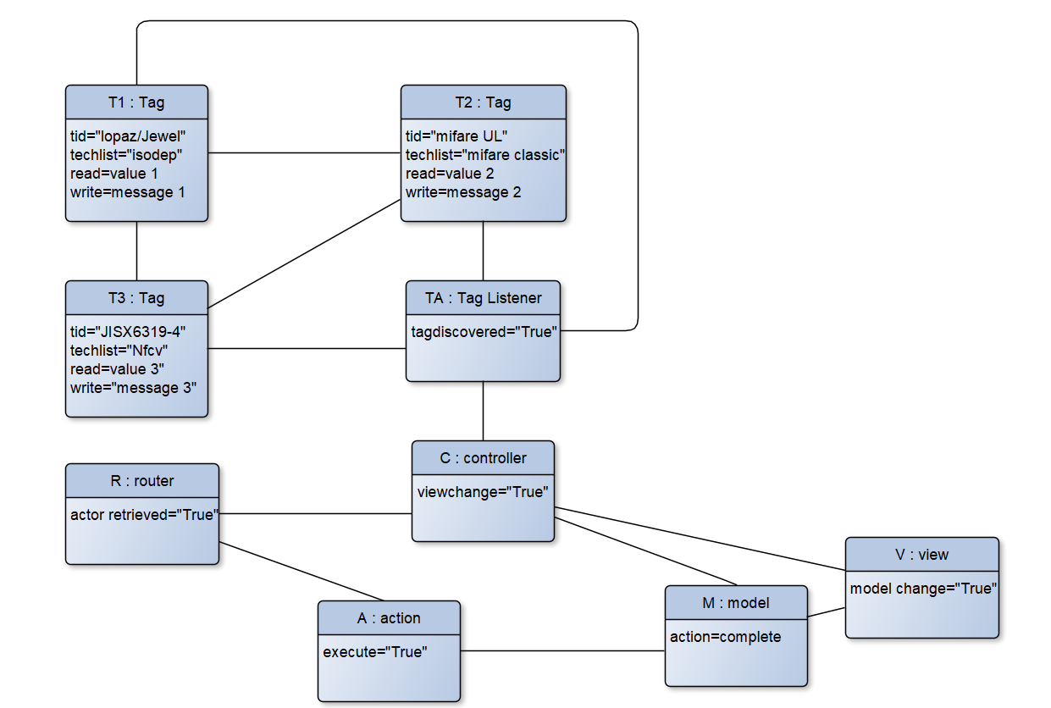

1. State transition diagram

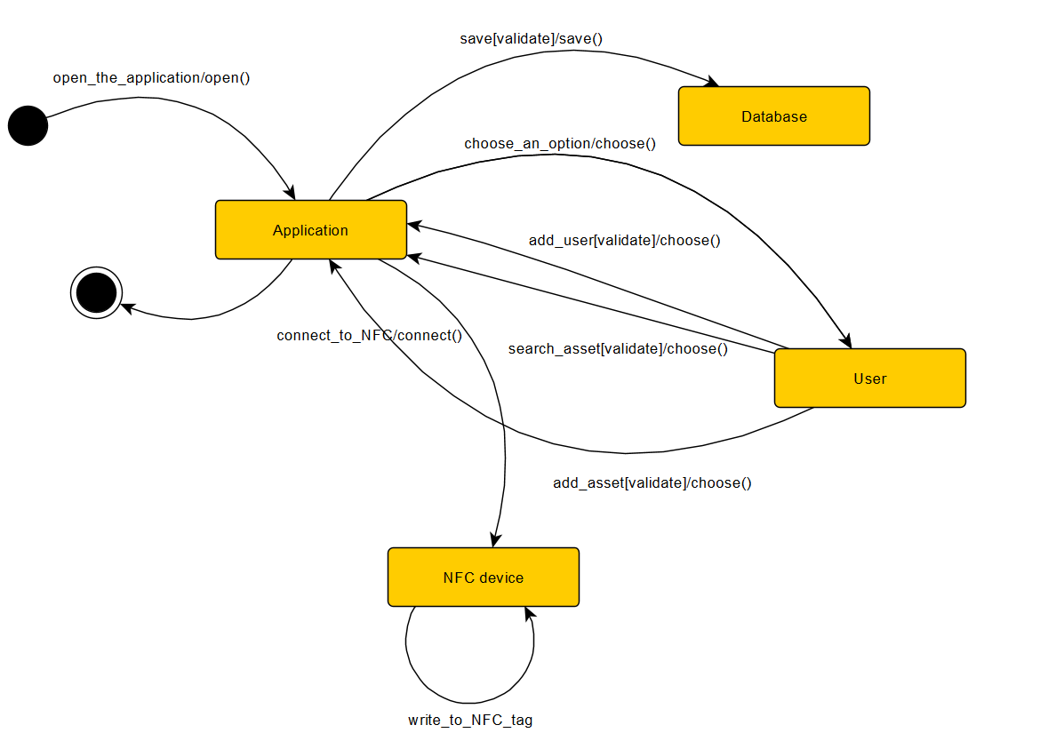

4.Component diagram

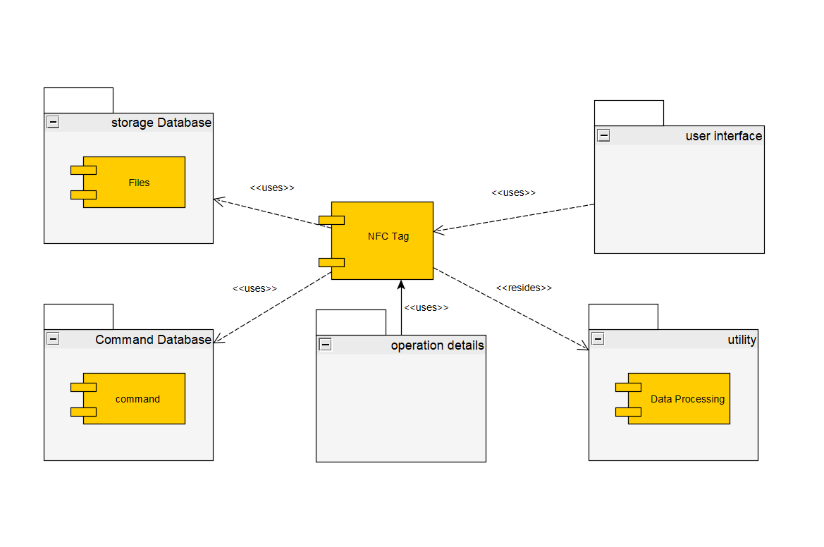

5.Deployment diagram

